

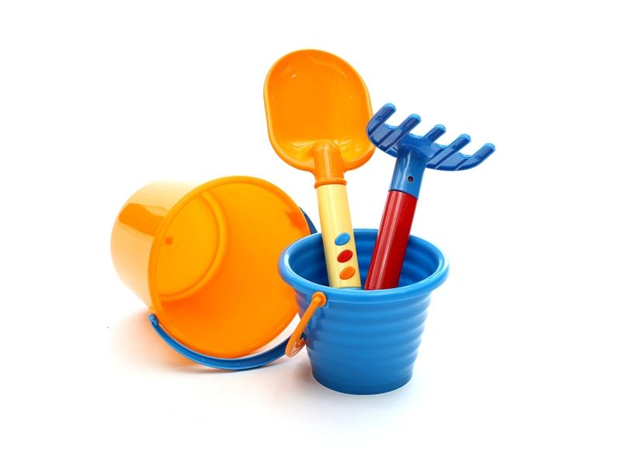
YOAKUM TOM-TOM FESTIVAL
KIDDIE PARADE
Friday June 5, 2026 | 6pm

This year’s Tom-Tom Kiddie Parade will be held Friday June 5th, DOWNTOWN. All children through age 12 are invited to participate. Check-in will start at 5:15 p.m. on Lott Street at Prosperity Bank; please be in your designated place by 5:45 p.m. The parade will begin at 6:00 p.m. and travel down Lott Street to the Yoakum Fire Department, where awards will be presented. Follow us on Facebook for more info. Please turn in entry forms by June 3rd to the Chamber office in the Community Center. Due to a high volume of parade participants, late entries will not be accepted this year.

This year’s theme: BEACH DAZE
____________________________________________________________________________
KIDDIE PARADE ENTRY FORM 2026

NUMBER OF PARTICIPANTS: ____________ Entry Title/Name: ___________________________

PARTICIPANT NAMES & AGES:___________________________________________________ ______________________________________________________________________________

BRIEF DESCRIPTION OF ENTRY (NAME, THEME, ETC.) TO BE READ BY ANNOUNCER: ____________________________________________________________________________________________________________________________________________________________
___________________________________________________________________________________________________________
______________________________________________________________________________________
SELECT THE APPROPRIATE CATEGORY:
___Walking Individual/Group ___Bikes & Trikes ___Wagons & Wheels
___Battery-Powered Vehicles ___Floats (man-powered/no vehicles)
___Pets ___Organizations/Clubs

PARENT NAME(S) ______________________________________________________________
ADDRESS ____________________________________________________________________
CELL PHONE __________________________________________________________________
EMAIL ______________________________________________________________________

The Yoakum Area Chamber of Commerce, along with its employees, members, and volunteers assume no liability for accidents or loss of property before, during, or after the kiddie parade. I have read and agree to this statement by my signature below.

CONTACT SIGNATURE_____________________________________________DATE__________________________

